CURRICULUM VITAE

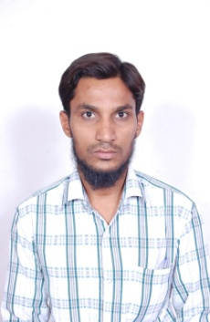

Email Ids:
mdnayeem792@gmail.com

Mobile No: +918801744081.
NAYEEM PASHA


Address: 19-3-201/C/9/2,
Acchi Reddy Nagar, Jahanuma,
Falaknum, Hyderabad, PIN- 500053,

Telangana, India.

CAREER OBJECTIVE:

To work on a challenging job profile which provides an opportunity to enhance my technical skills and knowledge ,this could provide me an insight into new aspects so that it would be helpful for my carrier.

EDUCATIONAL QUALIFICATIONS

Bachelors.(B.TECH) in Electronics and Communication (year 2010-2014) from JNTUH

Intermediate belongs MPC from Govt. Junior City Collage

s.s.c from Board of Secondary Education (bostown mission high school)

ACADEMIC PROJECTS:

Mini project on Density Based on Traffic Control System
Major project on Voice Controlled Robot

TECHNICAL SKILLS:

COMPUTER SKILLS:
- MS Office.
- Typing Speed 55 WPM.
PROGRAMMING LANGUAGES:
- C, Embedded System, Microcontroller 8051,ARM7(lpc2148)
DESKTOP SUPPORT:
Microsoft Windows 2003//windows 7/windows 8

PERSONAL SKILLS

- Ability to work in a team and individual environment
- Ability to maintain good interpersonal relations
- Ability to adopt changing environment
- Dedicated & self motivated
- Punctual & hardworking

LANGUAGES KNOWN:

- English.
- Hindi.

PERSONAL PROFILE:

Name : Nayeem Pasha

Father’s Name : Mohd Kareem

Religion : Muslim

Date of Birth : 11-05-1992

Place of Birth : Hyderabad

Nationality : Indian

Marital Status : single

Hobbies : cricket, Browsing net etc.

Address : 19-3-201/C/9/2, Acchi Reddy Nagar, Jahanuma,
Falaknum, Hyderabad, PIN- 500053,
Telangana, India.

E-mail id : mdnayeem792@gmail.com
Contact No: 8801744081
.

PERSONAL PROFILE:

I, Nayeem Pasha hereby declare that all the information provided is true to the best of my knowledge.

Place- Hyderabad
Date- (NAYEEM PASHA)

